Chapter 17

Maintenance and Reliability Decisions

**Background**

Some consider maintenance to be a rather “hidden” operations management strategy. Nevertheless, proper maintenance is absolutely vital to the success of companies because the costs of failure can be so huge. The Frito-Lay video associated with this chapter shows how seriously the company takes preventive maintenance activities, and the concepts described in the video fit in very nicely with the total quality management discussion from Chapter 6. Chapter 17 is short, but the concepts are crucial.

The reliability concept fits well in this chapter on maintenance, in particular because good preventive maintenance might improve the reliability of machines. Reliability also corresponds well with the chapter on designing goods and services (Chapter 5), because design engineers make conscious managerial decisions regarding the levels of reliability in their products. A scary quote to get the students interested in reliability could come from Ben Rich, former head of Lockheed’s *Skunk Works* operation: “[We need to determine] how to keep silo-based missiles reliable and effective after years of sitting inert in the ground. In some cases reliability has dropped below 50 percent.” (Rich, Ben R. and Leo Janos, *Skunk Works*, Boston: Little, Brown and Company, 1994, p. 339)

**Class Discussion Ideas**

1. Have the students identify an organization (perhaps the university’s computer lab) that experiences frequent equipment or process failures. What could the organization do to improve the reliability of the equipment or processes, and could some of the improvement come through improved maintenance?

2. Preventive maintenance examples that students can relate to are the scheduled maintenance guide for their cars and the scheduled virus scans on their computers. These could be viewed as a “pay now or pay later” strategy. Find out how often students change the oil in their cars. For computers, in addition to virus scans, users can back up their files periodically just in case the system crashes. This not only provides a safety net, but it acts as a way to *increase repair capabilities*. Ask the students how often they back up their files.

**Active Classroom Learning Exercises**

1. As a way to convey the meaning of reliability before introducing the formulas, instructors can try a little experiment with the students. Bring up, say, 10 students and tell them that they are each 90% reliable workers per day. They will each be asked to “work” for 10 days. If they don’t “break down” after 10 days, they will receive $10 (or a lesser sum, depending upon the instructor’s personal budget). Their success during the day will be drawn from a random distribution (the =RAND() Excel function can be used, or perhaps some Dungeons and Dragons dice). Any draw above 90% means that the student failed and has to sit down. The students have three options for playing the game: (1) they can act independently with 90% reliability; (2) they can join with one of the other players to create a work team *in series*, where a successful day means that both of them *must* succeed; or (3) they can pick another student from the class to act as a 90% reliable backup for them, where a successful day means that only *one* of them has to succeed. For any players that survive 10 rounds of the game, Option (1) has a $10 payoff; Option (2) has a $20 payoff for *both* students; and Option (3) has a $5 payoff for both students. Probability theory suggests that no students who choose Options (1) or (2) will survive all 10 rounds (although some certainly might). Instructors with extra disposable income could even add more options, for example $30 each for a series of three workers, $40 each for a series of 4 workers, etc. It can be interesting to see what kind of decisions the students make. Are they risk-averse or risk-loving? Do they understand how difficult it would be to win with Option (3)?

2. A preventive maintenance exercise can be performed in class using dominoes. Bring up two teams of students. The teams are competing in a race to see which team can successfully stack *X* number of dominoes vertically (standing end-to-end) first. When it is a player’s turn on a team, he or she walks to the table, picks up a domino, and tries to place it on top of the stack. After returning to the starting point, the next team member goes, and so on. Team 1 has no other special instructions. Players on team 2, on the other hand, may adjust (re-align) the stack before they place their own domino. In any cases, if the stack falls, the teams must start over again. The trade-off in this game is testing *breakdown maintenance* (Team 1) vs. *preventive maintenance* (Team 2). Team 1 should be stacking faster but should have a higher chance of failure. The game could be run several times using different values for the height of the stack. Presumably, preventive maintenance should pay off more and more as the value of *X* increases. Provide candy or some other prizes as an incentive. Provide candy to the rest of the class for choosing the winning team.

3. For a reliability exercise, split the class into teams. Assign the same “product” to each team. The product should have several components in series, each of which has a different reliability. Allow backups to be added for some of the components. Provide each team with a “product improvement budget,” along with options for improvements and the cost of those options. For example, the budget constraint might be $10 per product. Each backup costs $3. Each 2% increase in reliability costs $1 up to 99%, and each 0.2% increase after that costs $1. Yet another option might allow for *two* rather unreliable backups for the same component at a total cost of $3. Give the teams about 10 minutes to determine how to best spend their budget in order to increase reliability the most. This exercise can be performed either before or after the reliability formulas have been discussed (if before, students who read the book before class would certainly have an advantage!). After 10 minutes, compute the overall reliability for each team’s chosen strategy (a pre-set Excel spreadsheet can speed the calculations). Give the winning team members a prize. The different strategies utilized can help to answer the following types of questions: (1) Is it better to improve one component by 4% or two components by 2% each? (2) Is it better to add 2% reliability to a component with higher or lower initial reliability? (3) Is it better to install one good backup or two poor ones?

**Company Videos**

1. *Maintenance Drives Profits at Frito-Lay (8:03)*

Good maintenance practices are crucial for process industry companies such as Frito-Lay because high utilization levels of extremely expensive equipment are demanded. At Frito-Lay, good maintenance ensures reliable processes, which drive low cost, high quality, safety, and people engagement. Machine operators play a critical role in preventive maintenance at the company. Training helps operators become experts on their machines. Operators and maintenance personnel are assigned significant responsibility for maintenance issues, and they have the authority to shut down the line for a perceived maintenance problem. Frito-Lay practices TPM and 5S, which are both described in Chapter 17. The company has a program called “Run Right,” with three features: (1) a mid-shift and post-shift review of critical performance metrics, (2) “power walks” with critical experts and operators to ensure that machines are set at the proper levels, and (3) a maintenance and operations board where operators can post maintenance issues that need to be addressed in the future. Finally, the company makes sure that workers on shifts that are ending communicate with the incoming workers so that any issues about the line are monitored and handled appropriately. The employee empowerment concepts utilized by Frito-Lay tie in nicely with the total quality management material in Chapter 6.

Prior to showing the video, instructors might ask students to think about ideas for involving line operators in the preventive maintenance practices of manufacturing firms. Afterwards, the students’ ideas could be compared with the measures that Frito-Lay takes. Further discussion could explore students’ opinions on whether or not they think that machine operators would actually *want* to have responsibility for preventive maintenance on their machines. Have any of the students worked in a factory, and would they have wanted to have preventive maintenance responsibility? Do they know any workers whom they think would not want such responsibility? Finally, the video does not mention this, but instructors could ask the students what types of incentive systems should be put in place to encourage line workers to take their preventive maintenance responsibilities seriously. What can change the task from being perceived as an extra burden into an empowered quality responsibility that would produce real results and be rewarded when executed properly and in good faith?

**Cinematic Ticklers**

1. *The Simpsons, Season 7: “King-Size Homer,”20th Century Fox Video, 2006 (1995-1996)*

Homer has become so fat that he now works from home. As he sits at his computer screen for the nuclear power plant, the screen asks him if he wants to “vent radioactive gas.” At first he replies “NO.” The computer comes back with, “Venting radioactive gas prevents explosion. Vent radioactive gas?” After Homer replies “YES,” gas escapes from the plant and burns up a corn field. The farmer exclaims, “Oh no! Paul Newman is gonna have my legs broke!”

**Presentation Slides**

INTRODUCTION (17-1 through 17-7)

Slides 6-7: The Global Company Profile of the Orlando Utilities Commission provides a perfect lead-in to the power and importance of preventive maintenance. The statistics in these two slides are rather staggering, with regard to both the amount of maintenance that is performed as well as the cost of downtime and the cost of failures. The potential $27 million crack was invisible to the naked eye. It was only detectable via the preventive maintenance dye tests, X-rays, and ultrasound.



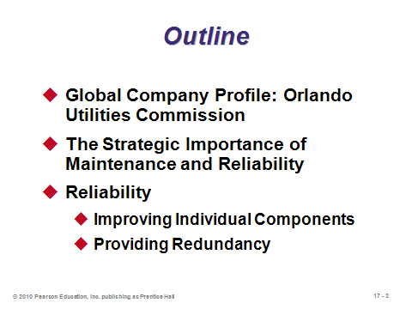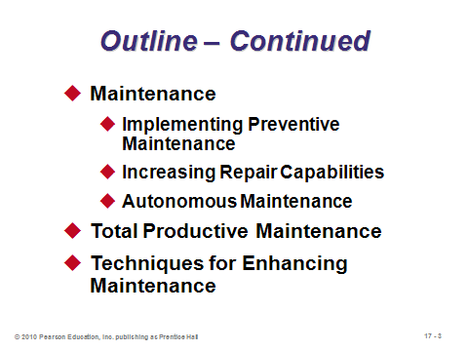

**17-1 17-2 17-3**

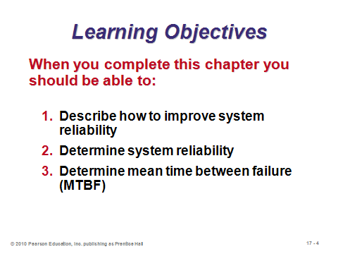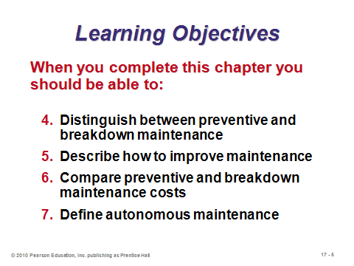

**17-4 17-5 17-6**

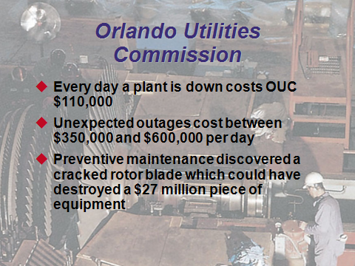

**17-7**

THE STRATEGIC IMPORTANCE OF MAINTENANCE AND RELIABILITY (7-8 through 7-12)

Slide 9: This list is not in the text. It provides a nice summary of the potential far-reaching implications of a system failure. Another potential disastrous consequence would be a safety hazard, possibly damaging the environment or even causing injury or death to employees, customers, or surrounding residents.

Slides 10-12: The respective definitions of maintenance and reliability are provided Slide 10. Slide 11 identifies two primary tactics for both. Slide 12 (Figure 17.1) illustrates that good maintenance and reliability management requires employee involvement and good procedures, resulting in enhanced company performance. The interdependence of operator, machine, and mechanic is a hallmark of successful maintenance and reliability.

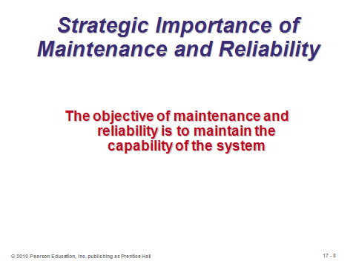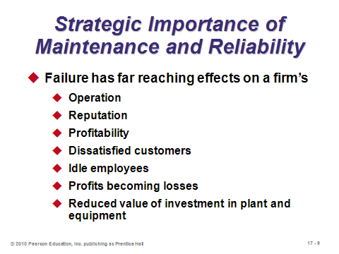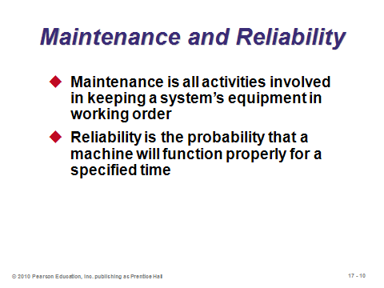

**17-8 17-9 17-10**

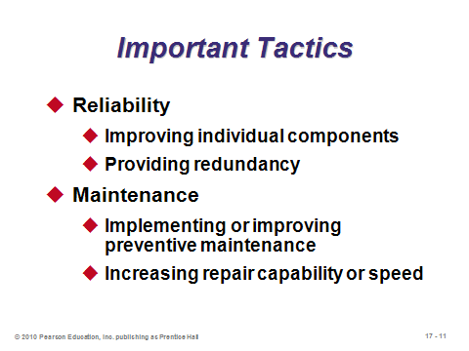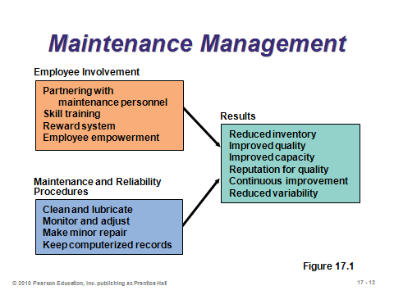

**17-11 17-12**

RELIABILITY (17-13 through 17-20)

Slides 13-15: Any component or system must have some probability of failure. If someone thinks it is 0%, then that person probably rounded too much. And while 99% reliability may sound like a high figure, it depends upon the context. If a 99% daily reliable dishwasher is run every day for a year, chances are that it will fail at least three times during the year—not very acceptable to most consumers. Furthermore, the *cost* of a failure should play a role in reliability. A manned rocket ship certainly needs to be more than 99% reliable, because the cost of a failure is catastrophic. Slide 13 presents the formula for the reliability of a system with *n* individual *independent* components that all must work in order for the system to work (referred to as components *in series*). (The independence assumption means that the probability of failure of one component has no correlation with the probability of failure of any of the other components—certainly true for some systems but not others.) The calculation is a simple multiplication of terms, but the implications may surprise students. As Slide 14 (Figure 17.2) graphically illustrates, the degradation can compound quickly. Here are three more examples: 10 parts at 90% reliability each would produce a 35% reliable system (0.9010); 100 parts at 99% reliability each would produce a 37% reliable system (.99100); and 1000 parts at 99% reliability each would produce a 0.004% reliable system (.991000) that essentially would never work at all (think about how many parts go into an airplane). This simple reliability formula has a clear implication for new product development. That is, try to limit the number of components in series in the product design (for example, consider a single molded interlocking part instead of using a hinge with four separate screws). Slide 15 (Example 1) provides a straightforward example of the system reliability formula.

Slides 16-18: The basic unit of measure for reliability is the *product failure rate* (FR). It can be described as the percent of failures among the total number of products tested (FR(%)) or as the number of failures during a period of time (FR(*N*)). Firms producing high-technology equipment often provide failure-rate data on their products. Perhaps the most common term in reliability analysis is the *mean time between failures* (MTBF), which is the reciprocal of FR(*N*). Slide 16 provides the formulas for all three measures. Slide 17 presents Example 2 from the text illustrating all three measures. Notice how the *Operating time* in the FR(*N*) calculation subtracts out the downtime during the two failures that occurred. Slide 18 converts the FR(*N*) value into a *failure rate per trip*, by multiplying the operating hourly failure rate by the length of a trip (24 hours times 6 days).

Slides 19-20: While it may be possible to increase the reliability of individual components, a more cost-effective approach may be to provide a backup for certain components. This is called *redundancy*, and the components are said to be operating in *parallel*. Interestingly, the reliability of the backup does not even need to be particularly high (say 50%) to improve overall component reliability substantially. Slide 19 provides the formula along with a sample problem. (Note that for this example, even if the backup had been only 50% reliable, the new reliability with redundancy would still have jumped from 80% to 90%.) Slide 20 (Example 3) provides a reliability example that combines components in series with components in parallel. Perform all of the backup calculations first for each component; then multiply all of the revised component reliabilities together.

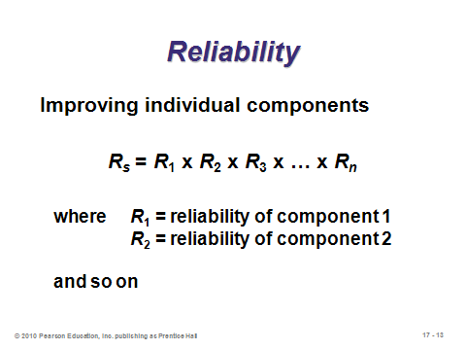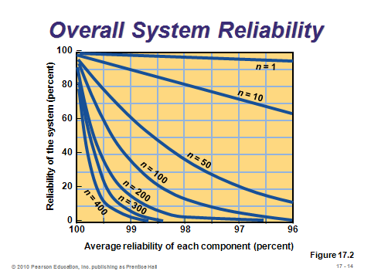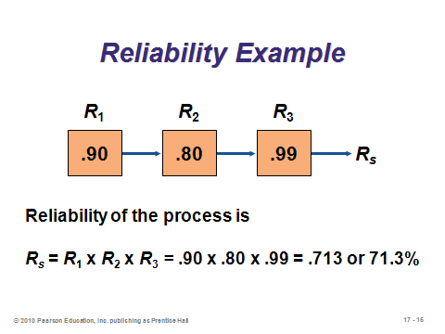

**17-13 17-14 17-15**

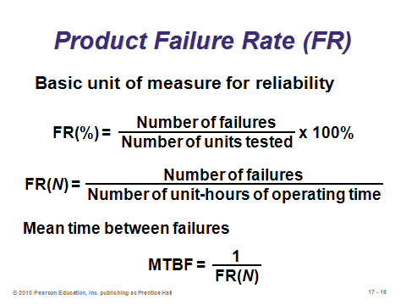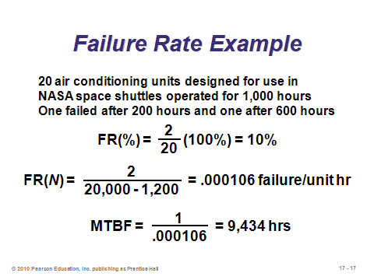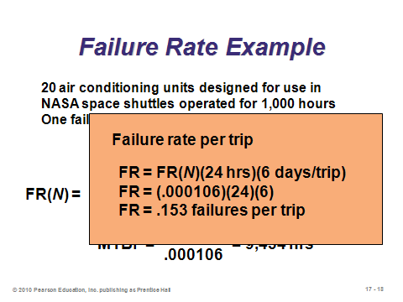

**17-16 17-17 17-18**

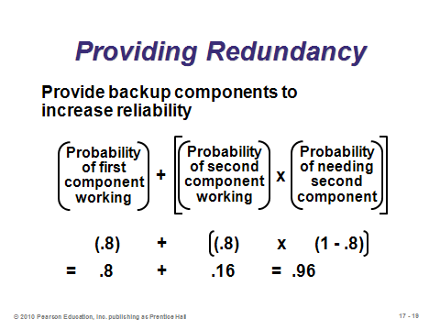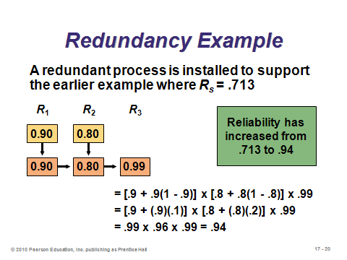

**17-19 17-20**

MAINTENANCE (17-21 through 17-33)

Slide 21: This slide describes the two basic types of maintenance. Performing more of the first usually mean having to perform less of the second.

Slides 22-23: Slide 22 identifies issues surrounding the implementation of preventive maintenance. Reliability and maintenance are of such importance that most systems are now computerized. Slide 23 (Figure 17.3) presents a schematic of a computerized maintenance system.

Slides 24-26: These slides address the traditional vs. an enlightened view regarding the amount of preventive maintenance to perform. Since the full cost of a breakdown may involve so much more than the repair cost itself (e.g., extra safety stock, safety, morale, customer relations, etc.), the implication is that the cost curve looks more like Slide 26 than Slide 25, implying that sufficient preventive maintenance should be performed to ensure that the system almost never breaks down.

Slides 27-30: These slides (Example 4) illustrate a cost analysis for preventive maintenance. No preventive maintenance would cost the firm $480 per month in breakdown costs. Purchasing a service contract for preventive maintenance would reduce the expected number of breakdowns per month from 1.6 to 1. Even after adding the cost of the service contract, the preventive maintenance option in this example was more cost effective, saving an estimated $30 per month.

Slide 31: A good maintenance facility should have the six features identified in this slide.

Slide 32: Since not all repairs can be performed in the firm’s facility, managers must decide *where* repairs are to be performed. This slide (Figure 17.5) provides a continuum of options and how they rate in terms of speed, cost, and competence. Moving to the right may improve the competence of the repair work, but at the same time it increases costs and replacement time.

Slide 33: *Autonomous maintenance* is consistent with employee empowerment (Chapters 6 and 10). System performance is enhanced when operators take ownership in their equipment and help to prevent breakdowns.

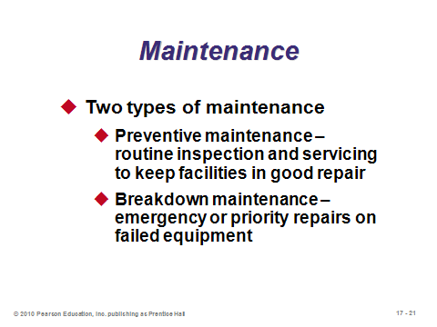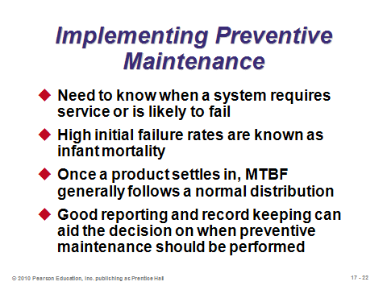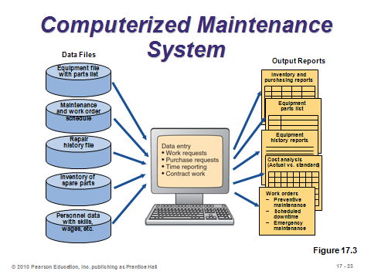

**17-21 17-22 17-23**

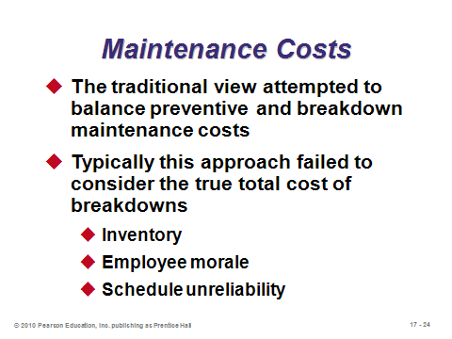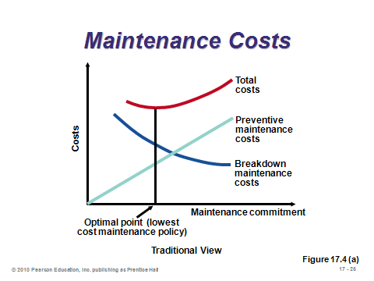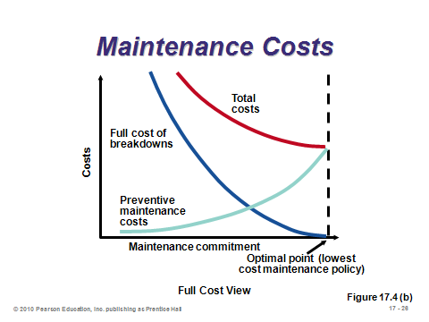

**17-24 17-25 17-26**

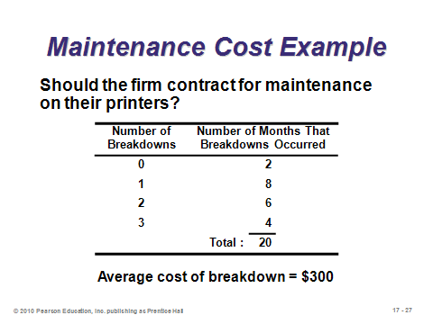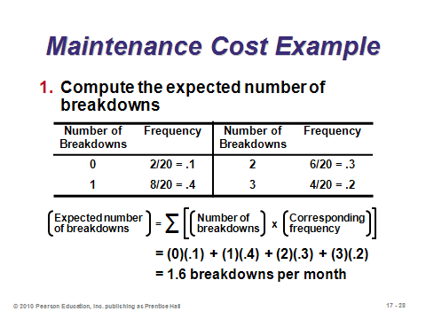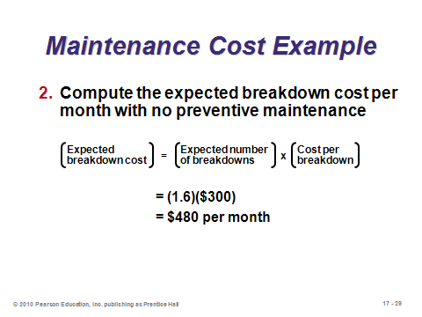

**17-27 17-28 17-29**

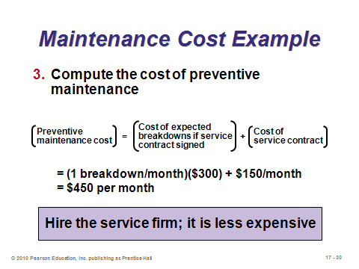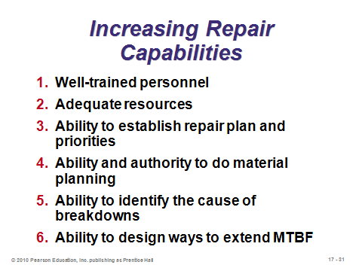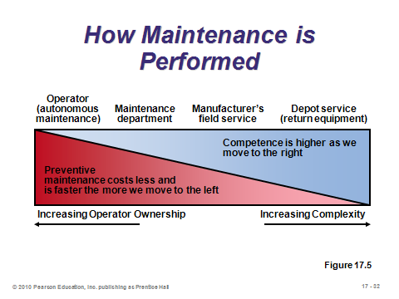

**17-30 17-31 17-32**

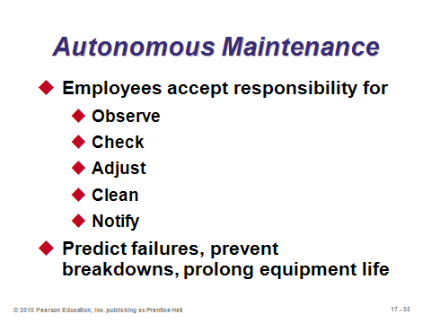

**17-33**

TOTAL PRODUCTIVE MAINTENANCE (17-34 through 17-35)

Slides 34-35: Many firms have moved to bring total quality management concepts to the practice of preventive maintenance with an approach known as *total productive maintenance* (TPM). This strategic view of maintenance includes the points described on these two slides.

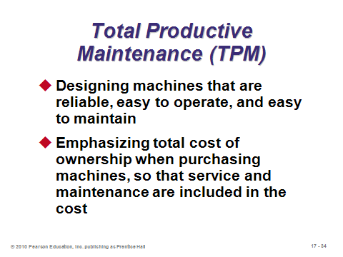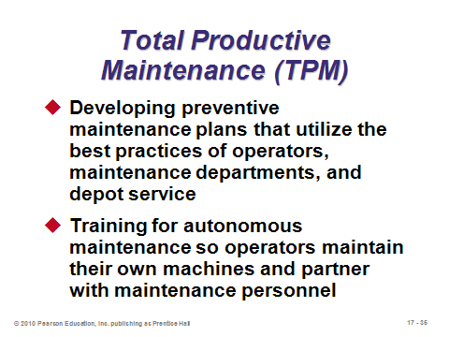

**17-34 17-35**

TECHNIQUES FOR ENHANCING MAINTENANCE (17-36 through 17-37)

Slides 36-37: The techniques described in this slide have proven beneficial to effective maintenance. An example of a physical simulation model would be vibrating an airplane to simulate thousands of hours of flight time to evaluate maintenance needs.

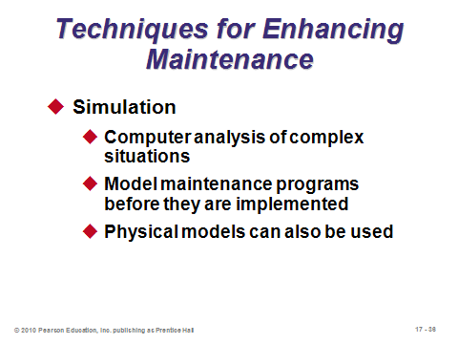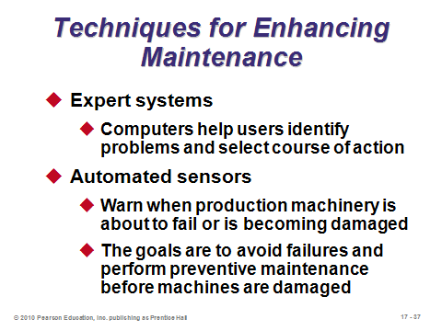

**17-36 17-37**

SUPPLEMENTAL MATERIAL (17-38 through 17-54)

Slides 38-54: Instructors who want to delve further into maintenance and reliability issues can select from this set of slides covering material not in the chapter. Most of the slides discuss the concept of *predictive maintenance*: using advanced technology to monitor equipment and predict failures.One note: from Slide 39, it is likely that fewer students will miscalculate the redundancy formula if it is expressed as:

Reliability = 1 – (Probability that the original fails)×(Probability that the backup fails).

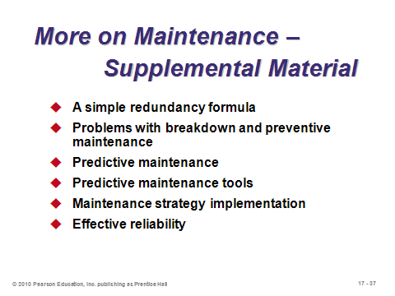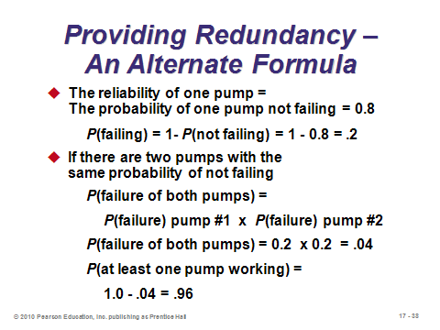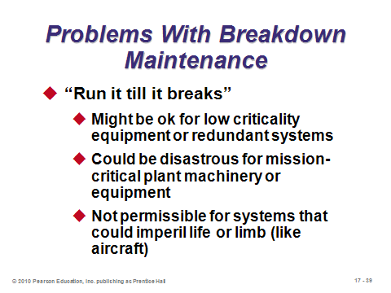

**17-38 17-39 17-40**

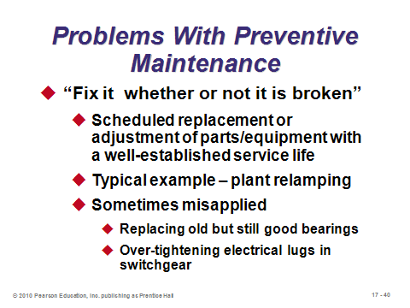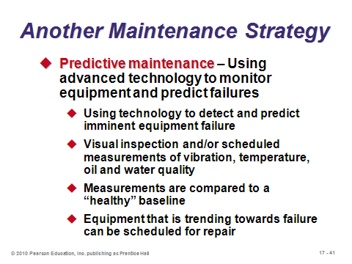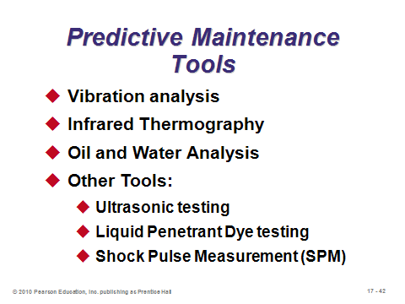

**17-41 17-42 17-43**

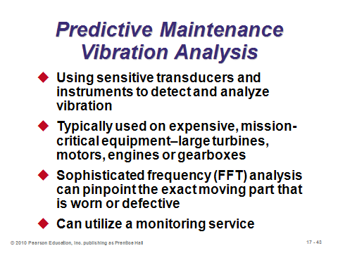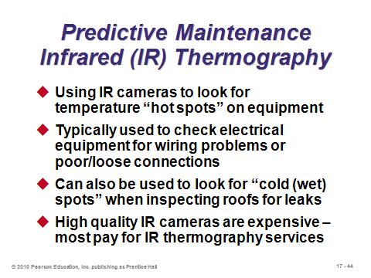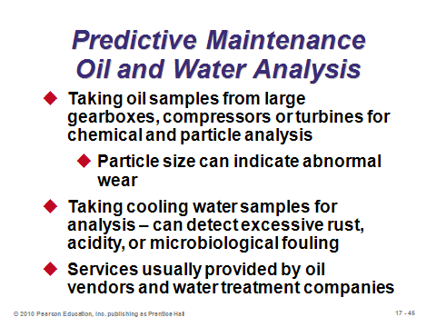

**17-44 17-45 17-46**

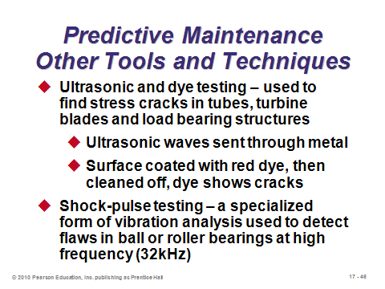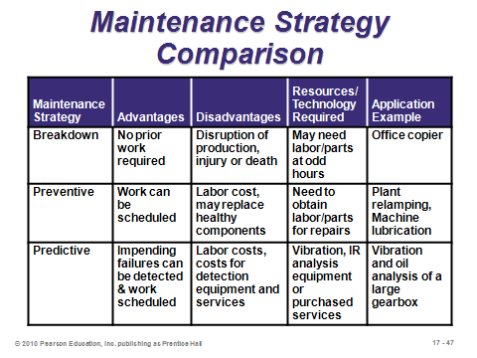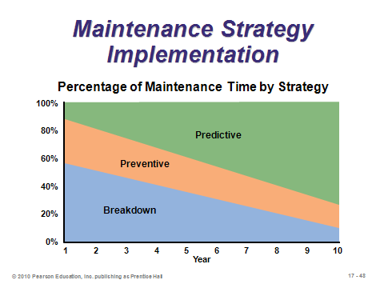

**17-47 17-48 17-49**

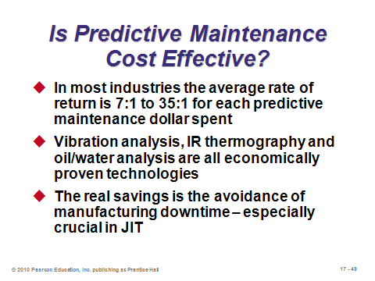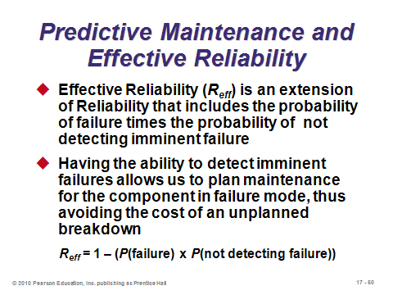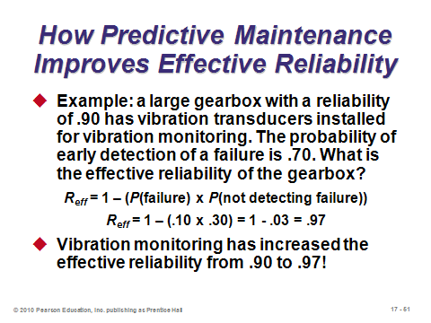

**17-50 17-51 17-52**

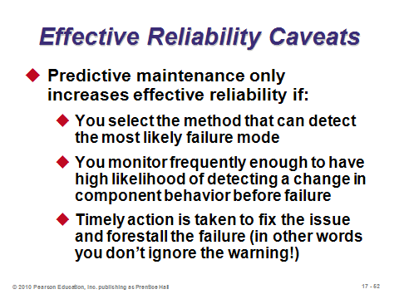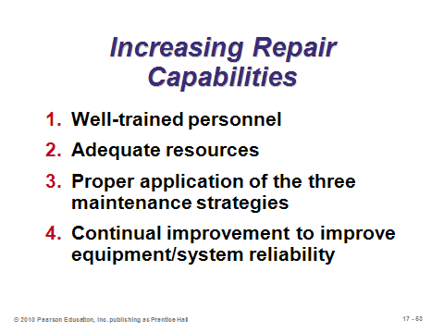

**17-53 17-54**

**Additional Assignment Ideas**

1. Maintenance and reliability management is a topic included in most Operations Management courses. Is this topic sufficiently complex that it requires a professional certification in and of its own (i.e., something more than the Operations Management certification of APICS)? What is the argument given by the Society of Maintenance and Reliability Professionals (http://www.smrp.org/)? Does the SMRP argument place more emphasis on benefits to the organization or to the individual?

2. Interview a manager of a manufacturing plant regarding the firm’s preventive maintenance policies. Write a report describing the firm’s practices, including detailed scheduling information, if available.

**Additional Case Studies**

Internet Case Study (www.pearsonglobaleditions.com/heizer)

* *Cartak's Department Store*: Requires the evaluation of the impact of an additional invoice verifier.

Harvard Case Studies (http://harvardbusinessonline.hbsp.harvard.edu)

* *The Dana-Farber Cancer Institute* (#699-025): Examines organizational and process characteristics that may have contributed to a medical error.
* *Workplace Safety at Alcoa (A)* (#692-042): Looks at the challenge facing the manager of a large aluminum manufacturing plant in its drive for improved safety.
* *A Brush with AIDS (A)* (#394-058): Ethical dilemma when needles penetrate container walls.

Richard Ivey School of Business (http://cases.ivey.uwo.ca/cases/pages/home.aspx)

* *Reliability Life Data Analysis for Decision Making* (#9B06E011): Two military vehicles were tested to obtain reliability life data for reliability evaluation. The objective of this case is to introduce reliability concept, MTBF, life data analysis and objective procedure for a decision-making.

**Internet Resources**

|  |  |
| --- | --- |
| Alion System Reliability Analysis Center | rac.alionscience.com |
| Center for System Reliability | reliability.sandia.gov |
| Reliability Engineering | www.enre.umd.edu |
| Society for Maintenance and Reliability Professionals | www.smrp.org |
| Society of Reliability Engineers | ww.sre.org |

**Other Supplementary Material**

Video

Film available from:

Society of Manufacturing Engineers

One SME Drive

P.O. Box 930

Dearborn, Michigan 48121-0930

(P) 313-425-3000

(F) 313-425-3412

http://www.sme.org

* *TPM: Total Productive Maintenance*: demonstrates how predictive and preventive maintenance techniques keep equipment operating at design specs. Order # PI-VT492-3456

Article

This article from *Interfaces* applies decision analysis to the problem of deciding whether or not to perform preventive maintenance and whether or not to conduct reliability tests. It provides an excellent (and very readable for students) combination of Chapter 17 and Module A.

Mellichamp, Joseph M., David M. Miller, and O-Joung Kwon, “The Southern Company

Uses a Probability Model for Cost Justification of Oil Sample Analysis,” *Interfaces*, vol. 23, no. 3 (May-June 1993), pp. 118-124.

Reliability and a Cost of Failures Example

The book has a nice example of analyzing a preventive maintenance decisions based on expected breakdown costs. A similar kind of analysis can utilize the reliability formulas as they might be related to new product design. A sample example is provided here.

Cost of a failed part = $500

Current reliability = 90%

Demand = 80 units

Time Horizon = 1 period

Current expected failure cost per part =

*$500×P(failure)*

*= $500×[1 – P(success)]*

*= $500(1 − .90)*

*= $50*

Overall expected cost of failures =

*80 units × $50 per unit = $4000*

To options for improvement:

Option A—Spend $1000 to increase reliability to 96%

Option B—Spend $2000 to install a redundant process with the same reliability

Option A

Expected failure cost per part =

*$500(1 − .96) = $20*

New overall failure cost =

*80($20) = $1600*

Total cost of improvement plus failure =

*$1000 + $1600 = $2600*

Option B

New reliability =

*.90 + (.90)(1 − .90) = .99*

Expected failure cost per part =

*$500(1 − .99) = $5*

New overall failure cost =

*80($5) = $400*

Total cost of improvement plus failure =

*$2000 + $400 = $2400*

In this example, both options are better than the current condition, but Option B is the better of the two and should be chosen. Note that combining Options A and B would improve reliability the most but *would not* be the optimal decision because the investment costs themselves would equal $3000, which already exceeds the total cost of Option B.